FROM: YOURNAME
YOURADDRESS
YOURCITYSTATE

TO LENDER: LenderName
LenderAddress
LenderCityandState

LenderName2
LenderAddress
LenderCityandState

TO TRUSTEE: TrusteeName
TrusteeAddress
TrusteeCityandState

ENCLOSURES: Exhibit A, Maricopa County Recorder’s Office
Exhibit B, Maricopa County Recorder’s Office

RE: Cease and Desist; Findings of fraud, misconduct, forgery; Reservation of rights; Obligations of defendants; Wrongful neglect and severability
Original Creditor: LenderName
Account Numbers: Loan# LOANNUMBERS

NOTICE: Cease and Desist, Request for correction under ARS 33-420C (Section 4b of this letter)

To Whom It May Concern:

Section 1) Cease and Desist:
Please accept this correspondence as notification of enforcement of my rights as a victim of fraud and forgery. a) I am requesting that you immediately cease and desist any further telephone based communication with me with relation to any and all alleged debts, including any debt for account number LOANNUMBERS. b) I also request that you discontinue any further communication with my family members, neighbors, friends, and any other party you may try to contact with regard to this issue. c) Furthermore, you shall cease and desist the reporting of negative or potentially negative information regarding my financial situations, credit standings or liabilities to any third parties including credit reporting agencies [entities such as Equifax, Experian, TransUnion, ChoiceTrust, ChexSystems]. d) I request that you immediately stop making any claims to me or my property that are false, that are based from/on illegal activities or that are intentionally misleading. e) I request specifically that you immediately stop any attempt to foreclosure actions against me.

Section 2) Findings of fraud, misconduct, forgery:
I have found evidence of illegal activities, fraud, misconduct and forgery committed by LenderName, its successors and its assigns, and TrusteeName, herein named the defendants, to the detriments of myself, YOUR_NAME, herein named the plaintiff. The plaintiff encloses exhibit A and exhibit B and claims that the attached documents, recorded in the County of Maricopa, by the defendants were not duly acknowledged under ARS 33-401 and 33-411.01, contained material false statements and are therefore invalid under ARS 33-417.

Section 3) Reservation of rights:
The plaintiff reserves all rights relating to this matter and specifically the rights:
- To notify anyone of the defendants misconduct.
- To seek/settle/secure reimbursement or compensatory damages for monies directly or indirectly paid by the plaintiff.
- To investigate all other documents recorded by the defendants as public record in the State of Arizona for similar behaviors and notify the persons involved, as a class, that they may be a victim of the defendants’ actions and to notify law enforcement and government agencies of the defendants’ actions.
- To seek/settle/secure punitive damages on the basis that the defendants’ actions have caused considerable undue stress, loss and burden on the plaintiff to the plaintiff’s demise.
- To hold the defendants liable for any damage to the plaintiff’s reputation or standing and for any benefit the defendants’ received from any third party known or unknown to the plaintiff.
- To bring before judicial review any of the matters stated above and attached with the intent of recovering damages from the defendants, to secure/enforce the plaintiff’s rights or to seek to have the defendants’ rights or abilities to operate or continue to do business in the State of Arizona revoked.
- To report any and/or each person working on behalf of the defendants that was a party to the fraud or directly related to the implementation of fraud to Arizona Department of Public Safety Document Crimes Division, a law enforcement agency.

Section 4) Obligations of the defendants:
The defendants are obligated to Cease and Desist as stated above but also to the following:
- to sequester all monies or properties the defendants gained or received in connection with their actions so that they are available for settlement or court order for the restitution of the plaintiff’s loss.
- to repair or correct the title documentation recorded in the County of Maricopa, this notice shall serve as my request for correction of the defendants’ actions as stated under ARS 33-420 C. The defendants have twenty days, as stated in ARS 33-420 C, to correct the paperwork or face further liability.
- to provide to the plaintiff a recording of all financial transactions, correspondence and actions taken by the defendants in connection with their illegal activities with the name and title of the person implementing, overseeing or responsible for the action clearly stated so that the plaintiff can better understand his rights and any benefit’s the defendants received from their actions.

Section 5) Wrongful neglect and severability:
Any article, clause, wording or section of this letter that is neglected, not carried out or not followed by the defendants that is within the legal rights of the plaintiff under the FCRA, Fair Debt Collection Practices Act, 15 U.S.C. section 805, Arizona Revised Statues, Arizona Administrative Rules, United States Code of Laws or the Constitution of the United States of America shall be considered, construed and constructed to be an intentional act by the defendant to further defraud, defame, damage, harass the plaintiff to the plaintiff’s peril and loss and to place an undue burden on the plaintiff. Any article, clause, wording or section of this letter that is found to be outside the scope of law or otherwise unenforceable, invalid or void shall not impair the validity or enforceability of any other article, clause, wording or section of this letter.

If you have been incorrectly named as being a party to the defendants’ actions of fraud, forgery and misconduct, please send me a statement sworn under penalty of perjury that you were not aware of the defendants’ actions or that some other circumstance absolves you of liability.

As a reminder to the defendants, all future contact to the plaintiff from the defendants and their assigns and their successors shall be in writing.

In the next forty five days, the plaintiff will send to the defendants a listing of all costs known to the plaintiff along with an offer to settle this matter without taking this matter to court. In the event of an inability for the plaintiff and the defendants to come to an agreement in the terms of settling this matter, it is the plaintiff’s intent to bring suit against the defendants in the County of Maricopa of the State of Arizona for their illegal actions against the plaintiff.

This is written without prejudice to the plaintiff’s rights, all of which are hereby expressly reserved,

YOURNAME
Exhibit A: Maricopa County Recording
Recording Number: 20060992173
Document: Warranty Deed
Available from http://recorder.maricopa.gov/

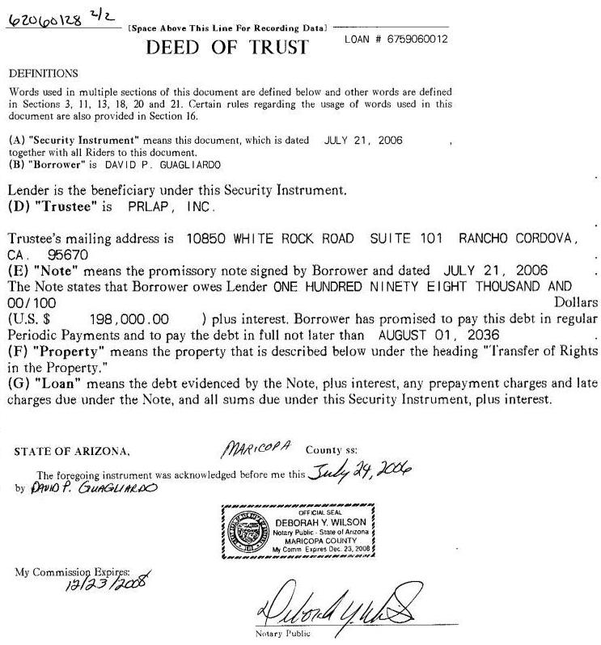

Document allegedly acknowledged three days after the document alleges it was signed.
Exhibit B: Maricopa County Recording
Recording Number: 20060992174
Document: Deed of Trust
Available from http://recorder.maricopa.gov/

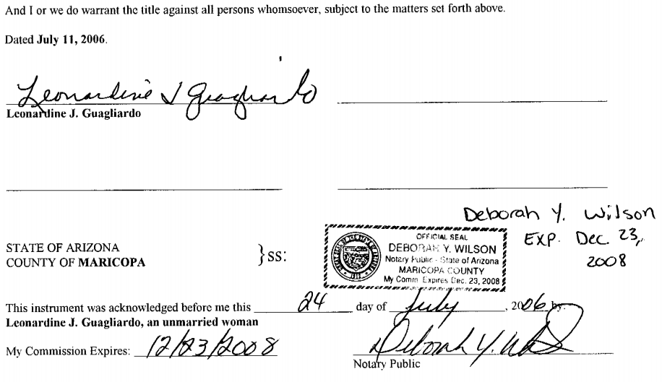

Document allegedly acknowledged thirteen days after the document alleges that it was signed.

