Justified Extortion
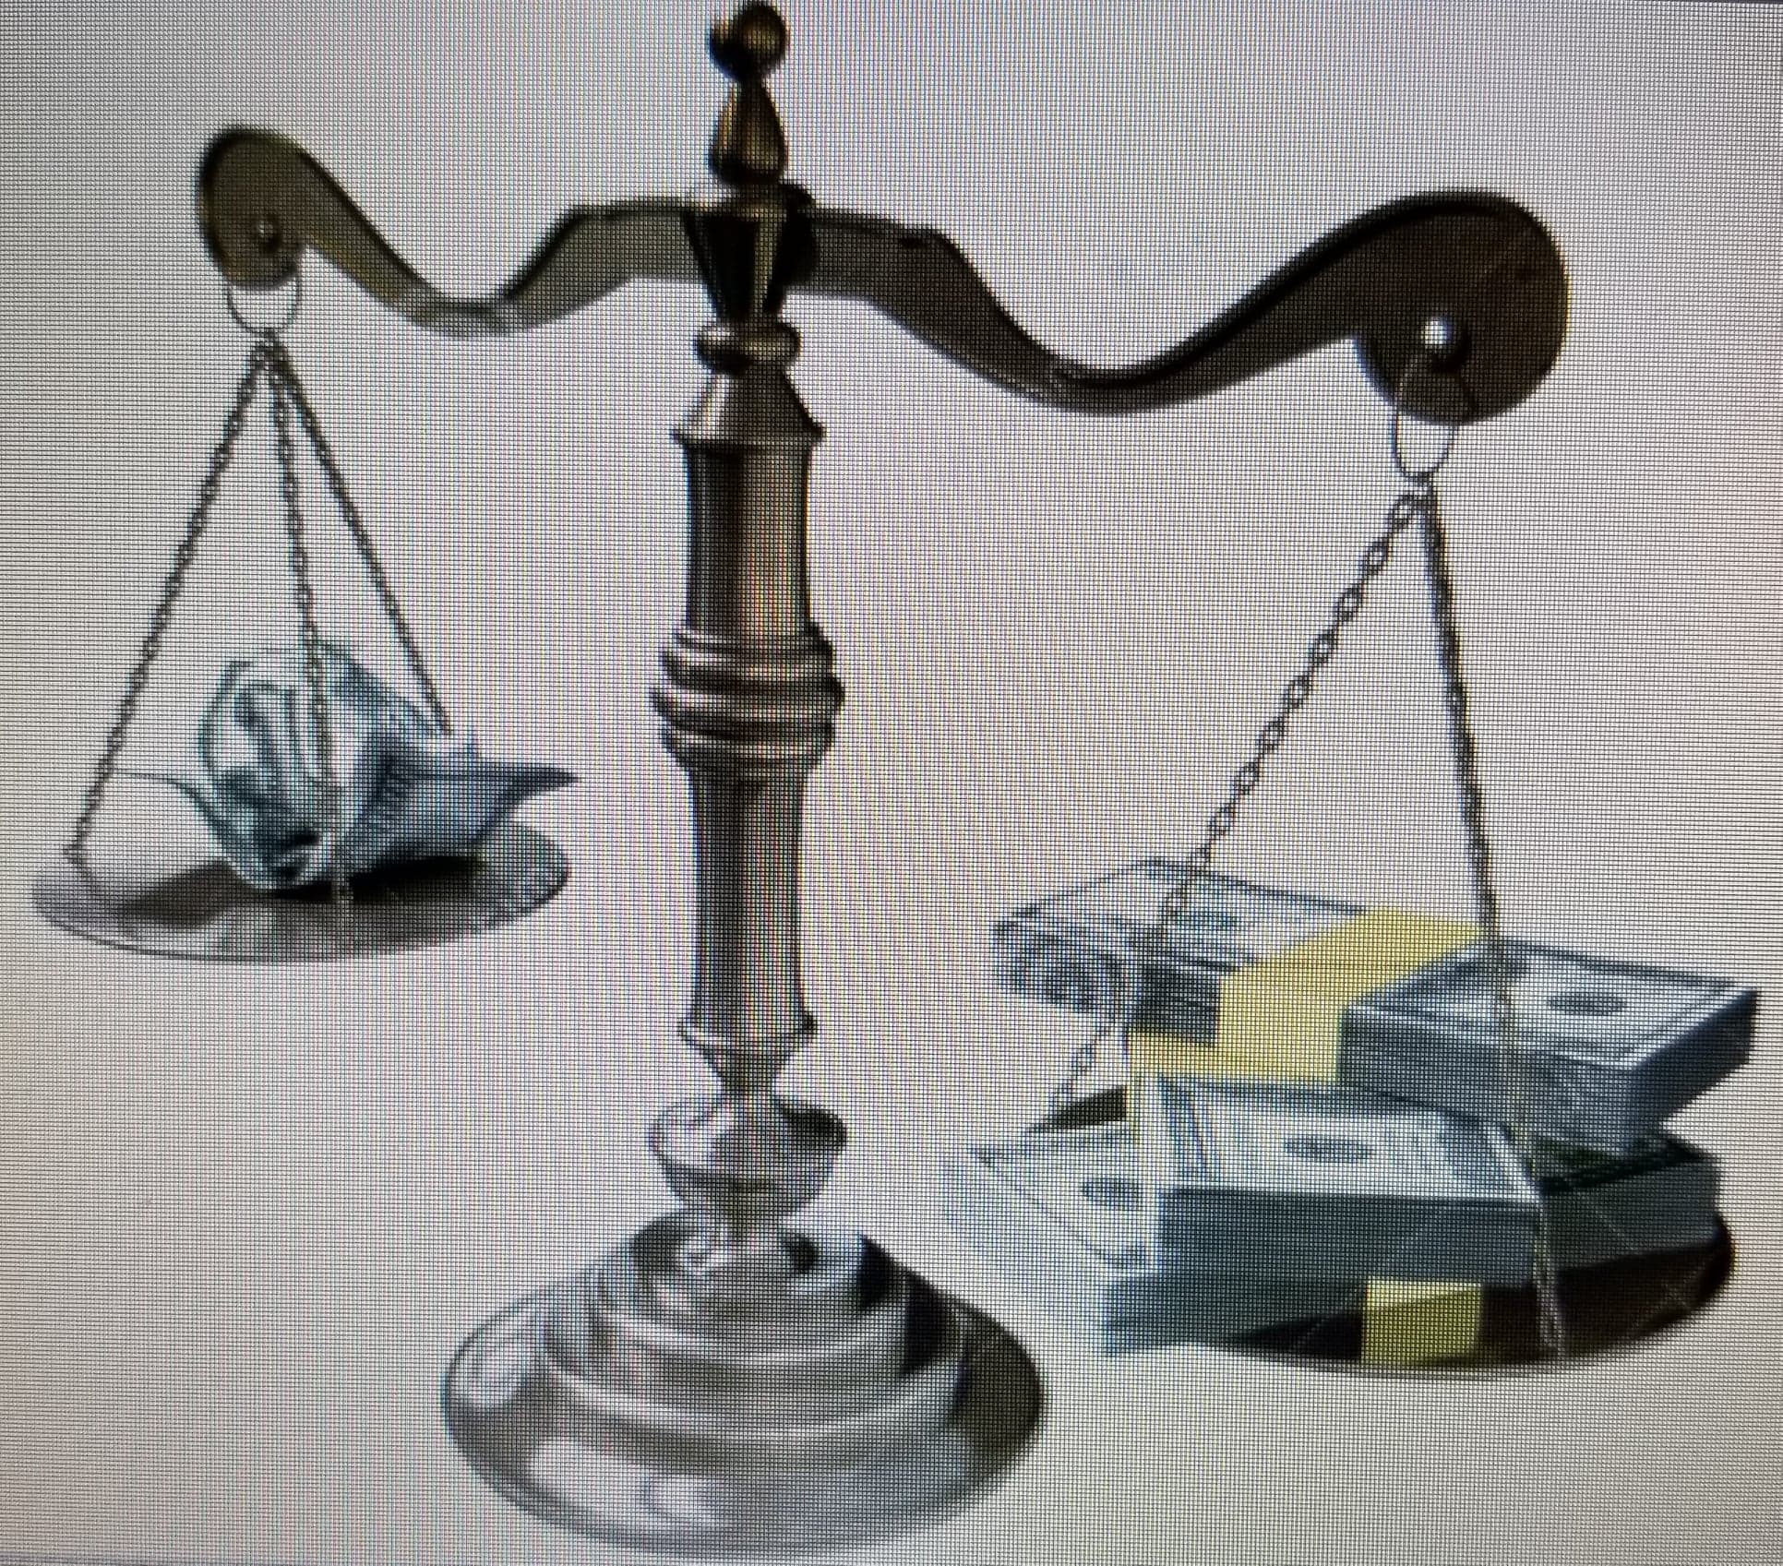
In a nation when the people limit themselves to internal conflicts with their fellow citizens and not damaging, secret, or abusive policies of governments, Quis custodiet ipsos custodes? (Who watches the watchers?)

A Memoir of Dan Benham

Justified Extortion

Simple reasons why corporate powers are protected to no end by government while the rights of the people diminish, little by little, until they are gone.
A real life documentary of what happens when one tries to expose the bigger problems underlying unlimited corporate and governmental powers in America in the name of fairness and justice to all.
The only cure is for the people to set aside their own divisions and prejudices and focus on the bigger picture will they have true individual freedom.

A Memoir of Dan Benham

Copyrighted © 2018 by Daniel D. Benham. All rights are reserved. No part of this book may ne reproduced, stored in a retrieval system, or transcribed in any form or by any means without express, written permission.
Printed in the United States of America
First printing December, 2018
ISBN
To order additional copies of ‘Justified Extortion’ visit or your favorite bookstore.

